**SUSTAINABLE OUTREACH AND UNIVERSAL LEADERSHIP LIMITED  
(SOUL)**



**STUDENT LIFE CYCLE MANAGEMENT**

**GAP ANALYSIS DOCUMENT (ACADEMICS)**

# **Introduction**

A gap analysis is an examination and assessment of the current performance for the purpose of identifying the differences between the current state of product and where you’d like to be.

Conducting a gap analysis can help us to improve our product and profitability by allowing us to pinpoint “gaps” present in our software. Once it’s complete, we will be able to better focus on our resources and energy on those identified areas in order to improve them.

# **Academics**

# Existing Student Academics Flowchart

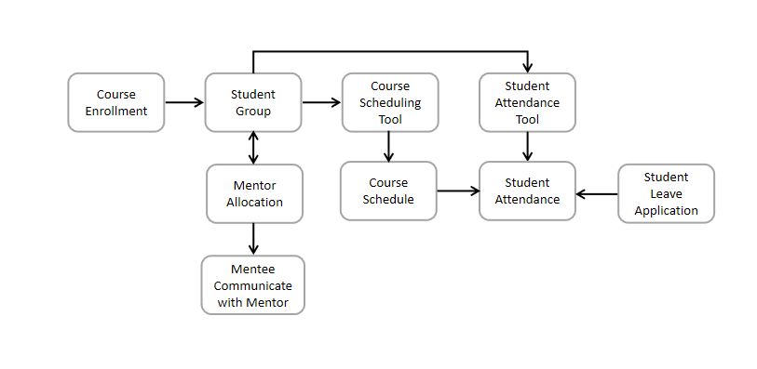

# acWSC Student Academics Flowchart

## **Groups & Schedules**

### **Student Group**

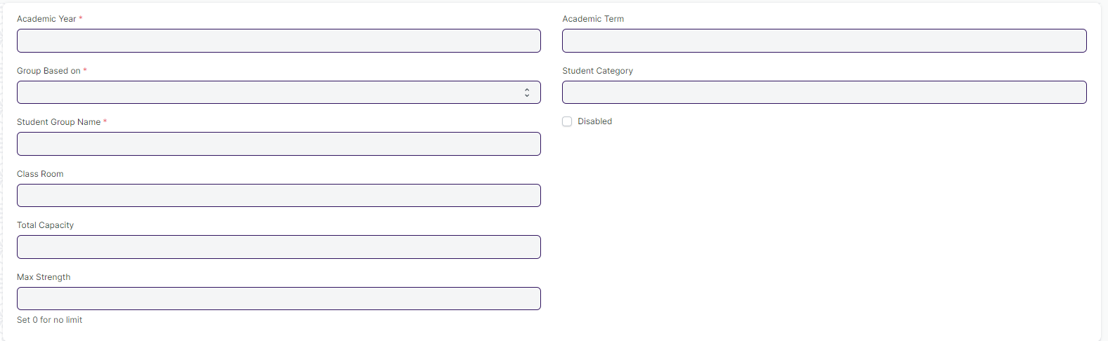

#### **Business Requirements:**

* Need to remove the Student Group based on Combined Courses and their respective fields such as Multiple Programs Table
* Programs and course name need to be rename to Course and Module.

### **Course Schedule**

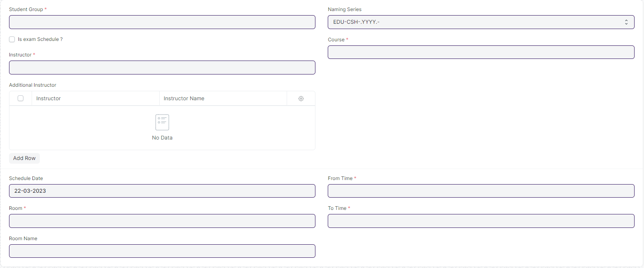

#### **Business Requirements:**

* No changes needed as discussed.

## **Attendance & Leave Application**

### **Student Attendance**

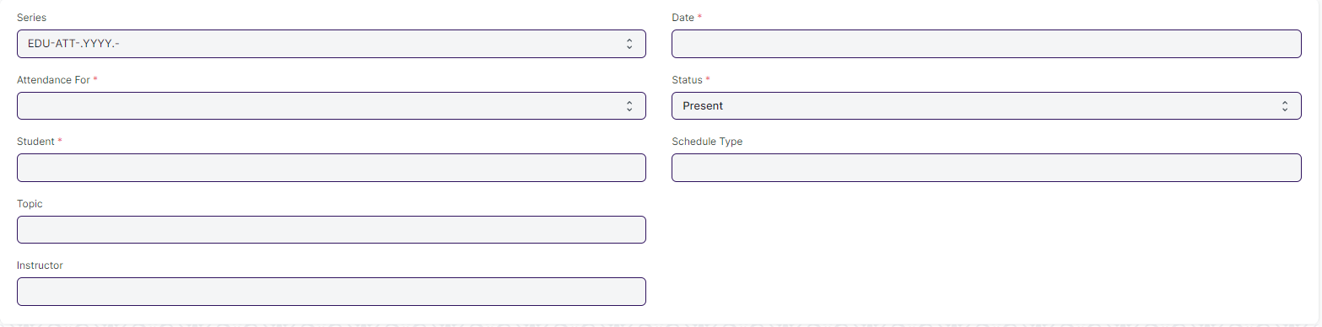

#### **Business Requirements:**

* In **Student Attendance** Screen Students attendance must be provided by an instructor before a specific deadline.

### **Student Attendance Tool**



#### **Business Requirements:**

* In **Student Attendance** Screen Students attendance must be provided by an instructor before a specific deadline.

### **Student Leave Application**

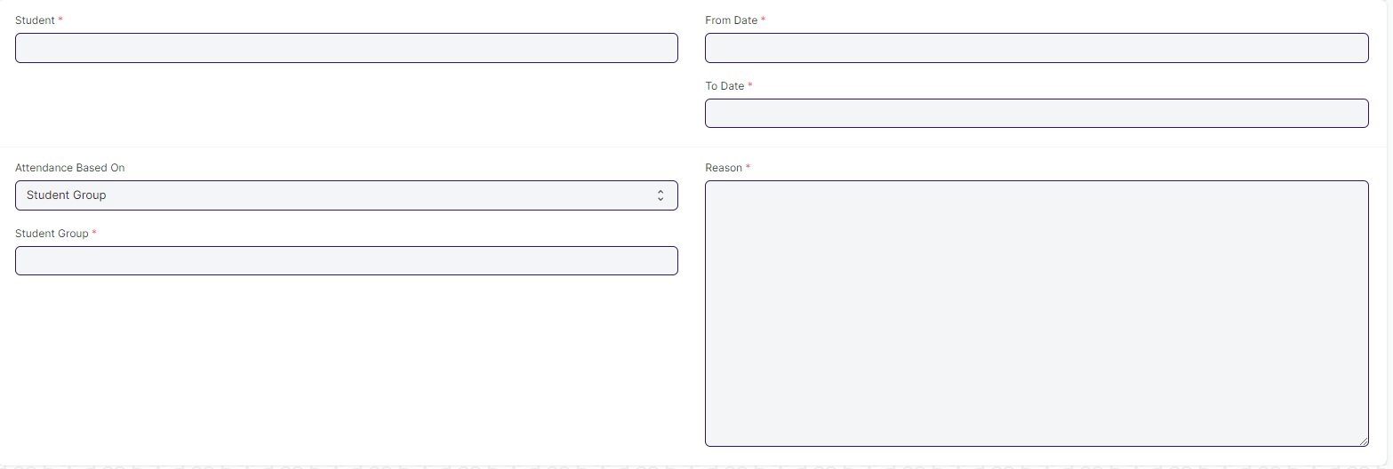

#### **Business Requirements:**

* A workflow needs to be added to the **Student Leave Application** screen where Class Advisor Role having the authority to approve the students leave Application.
* Workflow Actions: (Mail need to be triggered in every actions)

1. Approve
2. Reject
3. On hold

* Single Screen for Student Leave Application form
* Need to merge the two leave application form which are present in hostel and academic in to a single screen.

## **Mentor Mentee**

### **Mentor Allocation**

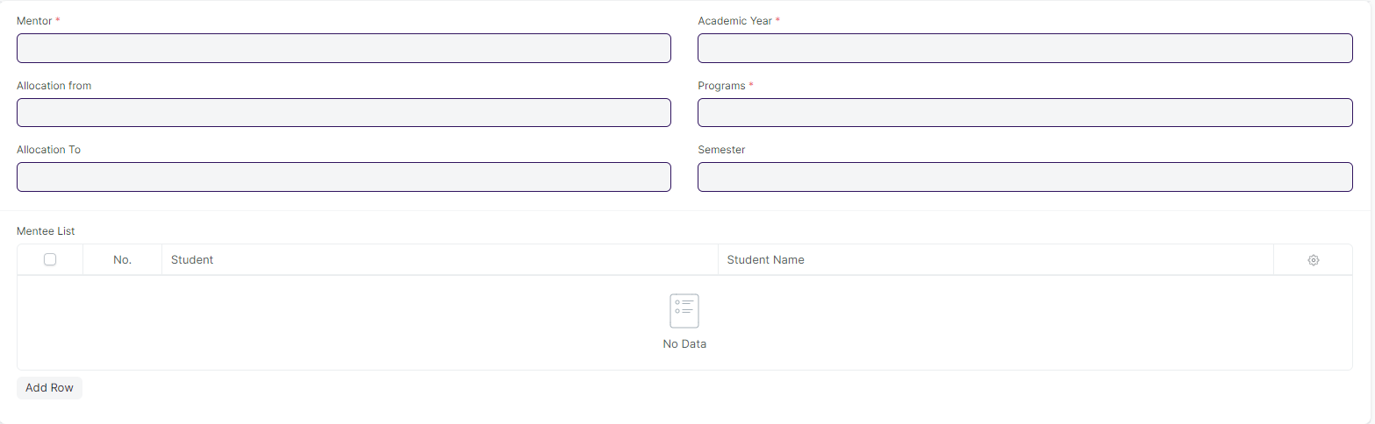

#### **Business Requirements:**

* Programs name need to be changed to Course.

### **Mentor Mentee Communication**

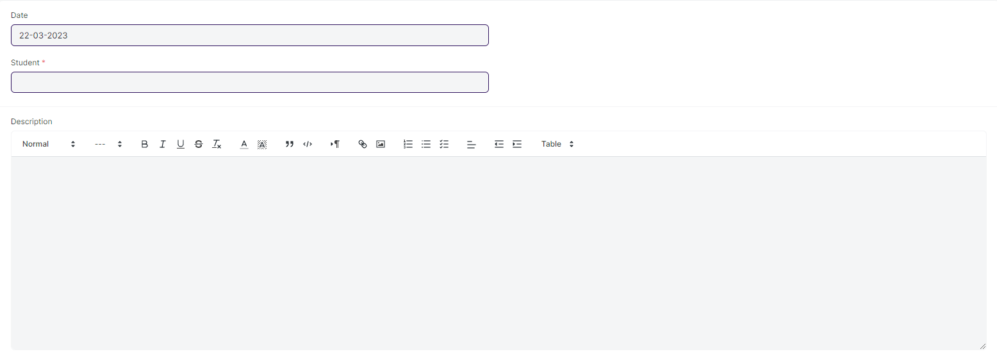

#### **Business Requirements:**

* In the **Mentor Mentee Communication** Screen, where mentors can message their students and a reply feature should be added so that mentors can respond to their respective mentees. (Notification need to be triggered to their respective mentees regarding the information given by the Instructor)

## **Tools**

### **Course Scheduling Tool**

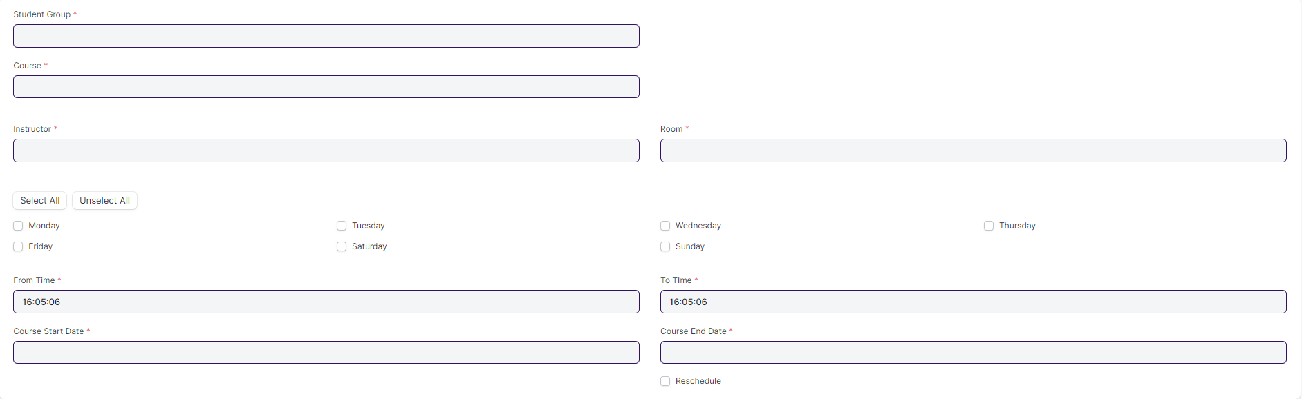

#### **Business Requirements:**

* Need to change the name of Course and Instructor to Module and Trainer.